**Team Profile**

# **Team Name**

To confirm again

# **Personal information**

**Ben Wakefield**

**Student number:** S3912783

**Student email:** S3912783@student.rmit.edu.au

Ben always had an interest in programming, drawing, and technology. He was born and raised in Australia and graduated from Springwood State Highschool in 2020. Being the quiet type, he likes to spend his free time playing video games with his friends. He hopes to pursue IT to broaden his knowledge and explore future career paths.

**Christopher Grimley**

**Student number:** S3912799

**Student email address:** s3912799@student.rmit.edu.au

Chris loves sci-fi horror movies. His interest in IT came as a blessing in disguise when a coworker convinced him to build a gaming PC. While learning about hardware and software, he faced endless problems that needed solutions, which sparked his interest in IT. He currently has a Certificate 3 in Information and Technology.

**Chevonne Cheng**

**Student number:** s3913877

**Student email:** s3913877@student.rmit.edu.au

Chevonne is a herbivore and mother of two adopted dogs: a Chow Chow and a mixed-breed street dog. She was born and raised in Singapore and previously studied marketing. After spending over 8 years in communications and advertising, she decided to pursue RMIT's Bachelor of IT degree to explore new IT career paths, preferably in a field that promotes a positive cause.

**Duc Hang**

**Student number:** s3675328

**Student email:** s3675328@student.rmit.edu.au

Hang is a raccoon-loving, Australian-born Vietnamese who is currently studying for a Bachelor of Business. Her interest in IT started when she was working as an inventory controller where she came across the concept of RFID. She has 6 years in the retail sector, over 3 years in supply chain and is studying to develop her knowledge and skills to hopefully have a career as a business analyst.

**Jason Hewitt**

**Student number:** S3912807

**Student email:** s3912807@student.rmit.edu.au

Jason loves the outdoors, taking his dog Beetlejuice to the beach, surfing, hiking and camping. Previously, he studied electrical engineering and currently works as an engineer, specifically in Industrial automation in the food industry. His career has taken him to all parts of Australia, Iceland, Denmark and the UK. He hopes to study IT to upskill himself for further career opportunities.

**Richard Jouas**

**Student number:** S3912523

**Student email:** S3912523@student.rmit.edu.au

Richard is a full-time systems administrator and Bachelor of IT student with RMIT. When he's not working or studying, he codes, writes his own apps or games, and reads about the latest tech developments. He enjoys playing racing simulations and Action RPGs/MMORPGs games and the guitar. He is also a big motorsport fan, and mostly watches Formula One and Indy Car racing. When he's not glued to his monitor, he enjoys the outdoors, hiking, and exploring new restaurants with a glass of beer or whiskey.

# **Team Profile**

### **—Ben Wakefield**

**Myers-Briggs Test Result:** ISTJ-T (Logistician)

**Learning Style:** Visual

[**MindTools Creativity Test**](https://www.mindtools.com/pages/article/creativity-quiz.htm) **Score:** 44

Ben has an ISTJ (Logistician) personality type. He is an introvert at heart, with a high Introverted Trait score of 87%. His primary learning style is Visual (40%), and his creativity is a work in progress.

Logisticians are known to be honest, direct, strong-willed and responsible. Like a typical ISTJ, Ben likes to work independently with set patterns and structure in his work. When these patterns do not match up, he would question why the project isn't working. Although Logisticians are fiercely loyal to their promises, their factual decision-making process may make it difficult for people with this personality type to accept their mistakes. They work best where there are concrete steps provided and clearly defined rules. However, this could prevent them from trying new things.

Ben thinks these results are quite accurate when describing him. He believes he is hardworking once motivated, and wants to achieve the best outcome through simplistic means. He enjoys learning how to implement HTML code, but only when he is not pressured by deadlines. As Logisticians may feel overwhelmed by responsibilities, Ben should be open to receiving feedback and help from others. Since he often prefers to work independently, he is often harsh on himself for making small mistakes.

Based on the information above, our team can learn to define tasks clearly and distribute workload evenly among teammates. Group members should be supportive of one another in order to help Ben find motivation in his work and hone his creativity.

Based on Ben’s visual learning style, he remembers things best by sight. Visual learners can absorb more information through reading or seeing vivid pictures, as they will be more easily distracted by sounds. Other recommended studying methods include using flashcards, visualising sounds and concepts, and drawing pictures or mind maps. Therefore, Ben should take notes down whenever he comes across new concepts. Ultimately, he believes he can fit in most teams, as he is usually committed and hardworking. To succeed, he would have to take one step at a time and set deadlines early.

### **—Christopher Grimley**

**Myers-Briggs Test Result:** ISFJ (Defender)

**Learning Style:** Tactile

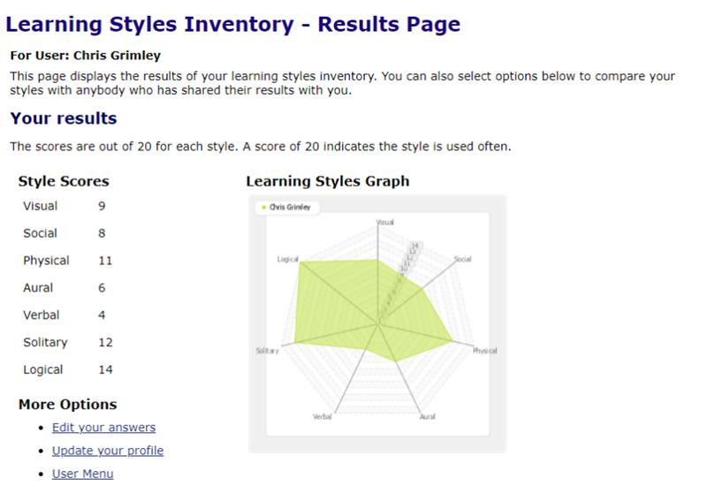

**Big Five Creativity Test:**

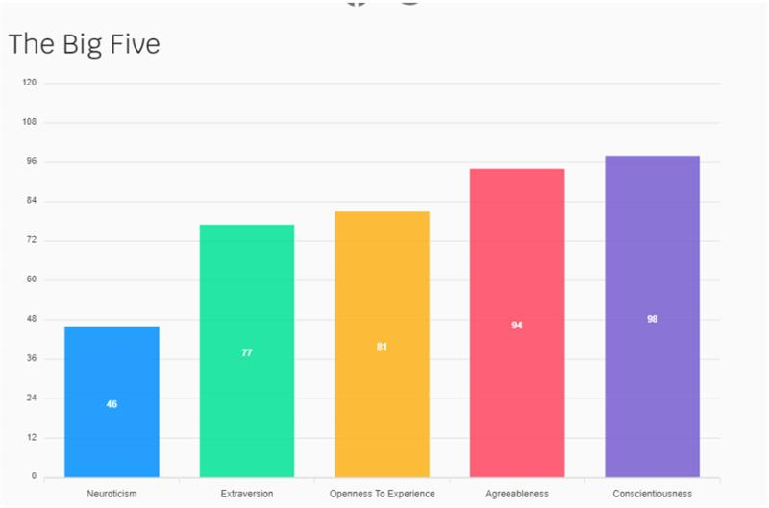

Christopher has an ISFJ (Defender) personality type. His primary learning style is Tactile Kinesthetic and he is highly conscientious, agreeable and open to experience.

Few personality types are as practical and dedicated as Defenders. They are known to be kind, practical, loyal, imaginative, dedicated and reliable. Risk-averse, traditional, factual, and conscientious, Defenders work best in stable, traditional, people-centric organisations. Although they may appear shy and quiet at times, they are deeply caring.

They are good at creating and maintaining a secure and stable environment for themselves and their loved ones. However, their kind and selfless nature could be a weakness when they are taken advantage of. Defenders often do not take credit for their contributions and may overload themselves.

The results of the test reiterates Christopher's most prominent personality traits, such as being very logical, observant and open to innovative ideas. He is interested in communicating ideas but would also be open to hearing other people's opinions and working together to find a solution. He can be relied on to complete his tasks and considers the wellbeing of his team mates.

Based on his Big Five personality test, he is very logical, observant, and open to innovative ideas. As a hands-on learner, he feels that he is better suited to working with others who have better verbal skills or perfectionistic qualities to complement his skills.

From the information provided, the team can learn to be fair, stable, organised and appreciative of one another. Christopher understands the benefit of working with people who have better verbal skills or perfectionistic qualities to complement his traits. He is best suited for hands-on roles and tasks that require attention to details.

### **—Chevonne Cheng**

**Myers-Briggs Test Result:** INFJ-A (Advocate)

**Learning Style:** Visual

[**MindTools Creativity Test**](https://www.mindtools.com/pages/article/creativity-quiz.htm) **Score:** 60

Chevonne has an INFJ-A (Advocate) personality type. Her primary learning style is Visual (55%), and creativity is one of her strengths.

Advocates are described as creative, idealistic, intuitive, principled, and passionate. They are known to be the rarest personality type in the Myers-Briggs spectrum. Due to their strong interpersonal skills and warm nature, they excel in conflict resolution and counselling work. Their decisions often reflect their moral values and they are best suited for careers in line with a cause they believe in, while having enough creative freedom in an open-minded, kind, and supportive workplace. Even though they have big dreams, they do take concrete steps to reach their goals.

However, their optimism can lead to negative outcomes. Advocates could be perfectionistic, sensitive, unwilling to open up, and prone to burnout. Assertive Advocates (INFJ-A) could get stuck focusing on the bright side, overlooking problems. Hence, they may need to withdraw from time to time to recharge and process their thoughts.

Chevonne feels that these results accurately describe what makes her tick. She leans towards careers that allow her to use her skills for a cause she believes in, such as animal welfare. Based on the information provided, she could be suited for tasks involving planning and innovating. She works best under a team leader who is more strict with deadlines and steps (possibly a Thinker/'T' type), as she may fixate too long on imperfections.

Being a highly visual learner, she learns best by drawing graphs, charts, maps, and other forms of colourful visual stimulation to absorb information. As creativity is her strength, she can also help to visualise how an end product or service may appear to consumers. By focusing on her strengths, she can take on more design-focused projects and components that require creativity and organisation e.g. team profile writing, editing, web design, agenda notetaking and brainstorming.

### **—Duc Hang**

**Myers-Briggs Test Result:** ESFJ-A (Consuls)

**Learning Style:** Tactile

**Big Five Creativity Test:**

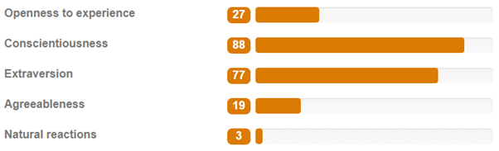

Duc has an ESFJ-A (Consul) personality type. Her primary learning style is Tactile (55%), and she ranks high in conscientiousness and extraversion.

Supportive and outgoing, Consuls can always be spotted at a party. They are known to be popular, practical, loyal, warm, emotionally intelligent and often make excellent managers. They have a strong sense of duty and enjoy keeping things stable and organised. If any group conflict arises, Consuls will try to restore harmony. Some of their weaknesses are described as being inflexible due to their preference for law and order, too selfless, and vulnerable to criticism.

Duc agrees she can be conflict-averse, disciplined, efficient, organised, and practical. However, she does not feel she is as vulnerable to criticism as described in the test results. Occasionally, she may struggle with improvisation due to her preference for conservative views and technical problem solving as opposed to imaginative and experimental.

Being more extraverted than introverted, she is open to forming teams with various types of people. Her Big Five test results reveal that she is outgoing, friendly and likes working with others. As a highly tactile learner, she learns best through creating or touching things and keeping active.

By understanding her strengths and weaknesses, she will keep in mind that others are not always as routine and structured as her. Our group can learn to rely on Duc to meet important deadlines, especially if we are running short of time, and leading presentations and meetings due to her extraverted and efficient nature. She is also relaxed, resilient and calm, which can help to keep the team grounded in tough situations.

### **—Jason Hewitt**

**Myers-Briggs Test Result:** ENTP (Debater)

**Learning Style:** Tactile

[**MindTools Creativity Test**](https://www.mindtools.com/pages/article/creativity-quiz.htm) **Score:** 52

Jason has an ENTP (Debater) personality type. His primary learning style is Tactile (45%), and his creativity is a work in progress.

Debaters are excellent brainstormers who have a constant thirst for knowledge and mental-sparring. They are charismatic and quick thinkers who are open to discussing abstract concepts and understanding problems from every angle. They have extremely flexible minds and are able to convey ideas in unique ways that are often entertaining and charming.

However, they can be argumentative and insensitive compared to other personality types who are less confrontational. Being so rational, they may misjudge others’ feelings when sharing their thoughts. Their ability to shift from idea to idea can also be a weakness if the novelty of fresh ideas wears off.

Jason feels that his personality results were scarily accurate. He enjoyed identifying both positive and negative aspects of his personality. He works well in a team environment, although working solo is preferred. To keep a happy team, it is important for him to consider the feelings of others and he tends to dismiss and overlook these when working in a professional team environment.

As a tactile learner, he also learns best through touching and doing things. Hence, we can assign him roles that involve physical activity. Tactile learners may have difficulty sitting still and remembering things they hear, so the team could take frequent breaks during long online meetings and take down notes for him to reflect back on. The team can also learn to give Jason more opportunities to share his ideas during discussions that will hone his creativity skills, as he is an excellent brainstormer.

### **—Richard Jouas**

**Myers-Briggs Test Result:** INTJ-T (Architect)

**Learning Style:** Mild Kinesthetic

[**Creativity Test**](https://vark-learn.com/the-vark-questionnaire/) **Score:** 62.19

Richard has an INTJ-T (Architect) personality type. His primary learning style is Mild Kinesthetic and creativity is one of his strengths.

Armed with powerful intellects and strategic minds, Architects can outmaneuver obstacles that seem unbeatable to most. They can be single-minded and driven, with little patience for frivolity and distractions. While many personality types trust the status quo, skeptical Architects aren’t afraid to break the rules. However, they may be overly critical of themselves and combative.

Richard identifies himself at times to the results above. He is persistent in his work, tries to push boundaries past the norm, believes in the best outcome, and learns from trials and errors. Known for being lone wolves, Architects may face challenges when working in a team. However, Richard’s professional experience has taught him to communicate/collaborate more and to take constructive criticism in order to create the best outcome possible for a team project.

For the learning style test, Richard picked the VARK Questionnaire. His learning preference is 'Mild Kinesthetic' — this means he is most efficient at studying using practical exercises, experiences, examples, case studies, trial and error, and tangible items. Kinesthetic learners have great hand-eye coordination and quick reactions.

Based on Richard's creativity test, creativity is one of his strengths, with persistence and boldness as his strongest points. Persistence is being able strive for better solutions even if good ones already exist. Boldness is having confidence in pushing boundaries beyond accepted conventions. Based on the information above, our team can rely on Richard to lead brainstorming sessions and ensure all members are committed to their tasks as he is highly strategic and innovative.